

Paramedic Training Program

Application Package
Fall 2016

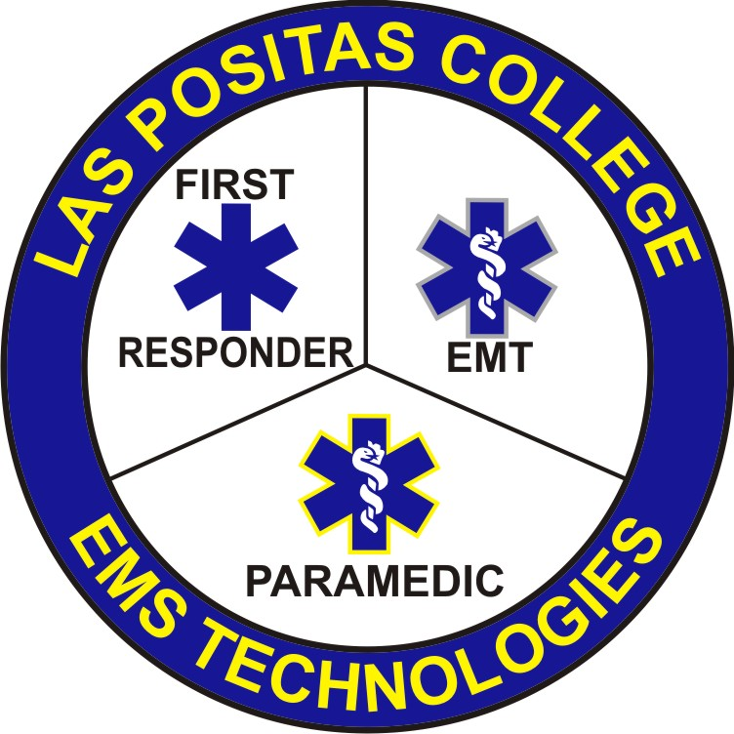

3000 Campus Hill Drive
Livermore, CA 94551
925-424-1354

Las Positas College Paramedic Program Application
For office use only
_______Student Application (Form A)
_______Personal Health History (Form B)
_______Physician’s Physical Examination (Form C)
_______Student’s Work Reference (Form D)
Date Completed: ___________________________________________
LPC Program Approval: ______________________________________
Acceptance Letter Sent: ______________________________________
_______High School Diploma/GED or equivalent
_______College transcripts
_______BLS HCP Card
_______EMT Certificate
_______Drivers License
_______Immunization Record
- □ Student Application
- □ Personal Health History
- □ Physical Examination Form
- □ Student’s Priority Registration Group
Application must include copies of the following:
- High School Diploma/GED or equivalent
- College Transcripts
      - *Identifying Completion of EMS 62 (Health 52) “Basic Medical Terminology” or Equivalent and Biology 50 “Anatomy/Physiology” or Equivalent
- BLS HCP Card
- EMT Certificate (Current State of California Certification)
- Immunization Record
- Screen shot or screen print of student’s Registration Priority Group webpage

Paramedic Application Due Date July 16, 2016 (5:00pm)

1 | P a g e

LAS POSITAS COLLEGE
Paramedic Program Information

Program Cost: $3,682.00 to $5,682.00 at $46.00 per unit

- Fees do not cover fees for Mandatory Field Internship (estimate $1,500 to $3,000.00)
- Fees do not cover cost of required textbooks or software
- Background and Criminal Check/Drug Testing (estimate $90)

LPC EMT-P Materials and Supply Fees will include:
- Laboratory Supplies and Materials (one use supplies for laboratory)
- Student Picture ID badge
- NREMT ALS Psychomotor fee (first attempt only)
- American Academy of Pediatrics PEPP training with card
- AHA ACLS training with card
- NAEMT PHTLS Course fees & card
- NAEMT TECC Course fees & card

Students shall be responsible to purchase separately the following items:

Uniforms:
- Dark Navy Blue Galls EMS Pants
- Black Basket Weave Belt with Silver Buckle
- Black EMS Duty Shoes or Boots (Recommended) *Tennis shoes or dress shoes may not be substituted for EMS footwear
- Scrubs for Clinical Rotations (Purchased through LPC)
- *Blue uniform shirts with Program Patch (Shirts Provided by LPC)

2 | P a g e

In order to achieve the paramedic curriculum objectives, a student must be able to:

- Assist in lifting and carrying injured and/or ill persons to and from the ambulance.
- Engage in pushing and/or pulling to assist in extrication of a patient pinned beneath and inside a vehicle, and in vehicles with electrical hazards.
- Walk, stand, lift, carry, and balance in excess of 125 pounds without assistance,
250 pounds with assistance) while lifting, pulling, pushing and carrying a patient.
- Stoop, kneel, bend, crouch and crawl on uneven terrain to gain access to a patient.
- Climb stairs, hillsides, and ladders to gain access to a patient.
- Communicate verbally in person, via telephone and radio equipment.
- Work in chaotic environments with loud noises and flashing lights.
- Perform patient assessments, implement treatment, and calculate weight and
volume ratios under threatening time constraints.
- Work effectively in low light, confined spaces, extreme environmental conditions and other dangerous environments while remaining calm.
- Perform fine motor movements while in stressful situations and under threatening
time constraints.

___________________________________________________ Date: ______________
Name of Applicant

Signature of Applicant

3 | P a g e

LAS POSITAS COLLEGE PARAMEDIC PROGRAM
(Form A)

Student Application

Name: _________________________________________ Date: _______________
First Middle Initial Last

Mailing Address: _______________________________________________________________
Street Apt. #
_______________________________________________________________
City Zip

Home Phone: ______________________ Cell/Other: ____________________________

Social Security: ______________________ W Number (LPC/Chabot):_________________

Employer: ____________________________________________________________________

____________________________________________________________________
Street Apt. #
____________________________________________________________________
City Zip

Employer Phone: _______________________ Supervisor: ___________________________

Circle Highest Level of Education: Less than HS Diploma HS/GED College 1 2 3 4

E-mail address: ______________________________________________________

Person to be notified in case of an emergency: ______________________________

Phone number of emergency contact: _____________________________________

I currently hold the following health/medical certifications or Licenses:

Please describe any previous professional health/medical work experience:

4 | P a g e

I have taken the following health/medical classes:

I have the following volunteer experience related to health/medical:

NOTICE: Please indicate by signing below, that you have read and understand the following statement: “State law requires Las Positas College to retain a Criminal/Background and Drug Screening test in the student application file prior to placement in a clinical setting”.
Have you ever been convicted of a felony? _______ yes _______ no

Yes, I have read and understand the program information and statement above. The information I have given in this application is correct, to the best of my knowledge.

Signature: ____________________________________ Date: _________________

5 | P a g e

LAS POSITAS COLLEGE PARAMEDIC PROGRAM
(Form B)
Personal Health History
To be completed by the applicant.

Name (Please Print):________________________ Date: _____________

Do you have a history of:
Heart disease Yes _____ No _____
Hypertension Yes _____ No _____
Tuberculosis Yes _____ No _____
Diabetes Yes _____ No _____
Epilepsy Yes _____ No _____
Seizures Yes _____ No _____
Migraine Yes _____ No _____
Frequent Headaches Yes _____ No _____
Arthritis Yes _____ No _____
Physical Disabilities Yes _____ No _____
Learning Disabilities Yes _____ No _____

Emotional/Nervous disorder Yes _____ No _____

If you answered “yes” to any of the above, please explain. ________________________________________________________________________________________________________________________________________________________________________
Have you even been treated for a back ailment or injury? Yes _____ No _____
If you marked “yes”, please explain. ________________________________________________________________________________________________________________________________________________________________________
Are you currently taking any medications? Yes _____ No _____
If yes, please list the medications you are currently taking. ________________________________________________________________________________________________________________

Student Signature: __________________________ Date: _____________________

(Form C)

PHYSICIAN’S REMARKS AND RECOMMENDATIONS
Las Positas College Paramedic Program
Physical Examination Form

_________________________________________ Date: _____________________
Student’s Name – Please Print
TO BE COMPLETED BY A PHYSICIAN. ALL AREAS MUST BE COMPLETED BEFORE FINAL ACCEPTANCE INTO THE PROGRAM.
Blood Pressure: _________________________ Pulse: ________________________
Height: ___________ ft. __________ in. Weight: ____________________lbs
Eyes: Vision: R__________ L_____________ Corrected: R__________ L ________
Hearing: R ___________ L _______________
Heart: _______________________________ Lungs: __________________________
Abdomen: _________________Hernia: _____________ Skin: _________________
Lifting Restrictions, if any: ____________________________________________________________________
Tuberculosis Skin Test: __________________________________________
Signature Date
___ Hepatitis B Vaccine record ___ Measles, Mumps & Rubella
Is this individual in suitable health, physically and emotionally, for EMS training? Yes____ No____
Comments/Recommendations: __________________________________________________________________________________________________
Physician Name:______________________________________________________
Physician Signature: ___________________________________________________

Phone#:__________________________
Address: ____________________________________________________________
Street City State Zip

